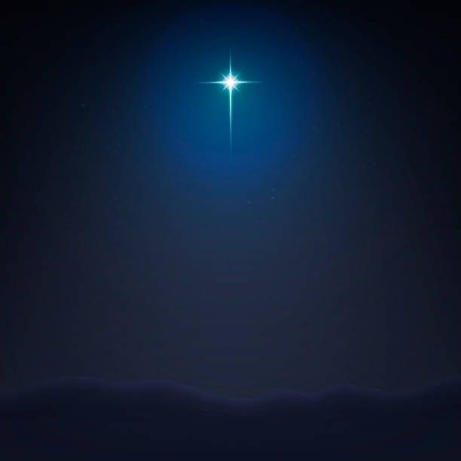
TheLine to Christmas
Ruth
Part 3

Ruth Chapter4

Ruth 4

1 Then went Boaz up to the gate, and sat him down there: and, behold, the kinsman of whom Boaz spake came by; unto whom he said, Ho, such a one! turn aside, sit down here. And he turned aside, and sat down. 2 And he took ten men of the elders of the city, and said, Sit ye down here. And they sat down. 3 And he said unto the kinsman, Naomi, that is come again out of the country of Moab, selleth a parcel of land, which was our brother Elimelech’s: 4 and I thought to advertise thee, saying, Buy it before the inhabitants, and before the elders of my people. If thou wilt redeem it, redeem it: but if thou wilt not redeem it, then tell me, that I may know: for there is none to redeem it beside thee; and I am after thee. And he said, I will redeem it. 5 Then said Boaz, What day thou buyest the field of the hand of Naomi, thou must buy it also of Ruth the Moabitess, the wife of the dead, to raise up the name of the dead upon his inheritance. 6 And the kinsman said, I cannot redeem it for myself, lest I mar mine own inheritance: redeem thou my right to thyself; for I cannot redeem it. 7 Now this was the manner in former time in Israel concerning redeeming and concerning changing, for to confirm all things; a man plucked off his shoe, and gave it to his neighbour: and this was a testimony in Israel. 8 Therefore the kinsman said unto Boaz, Buy it for thee. So he drew off his shoe. 9 And Boaz said unto the elders, and unto all the people, Ye are witnesses this day, that I have bought all that was Elimelech’s, and all that was Chilion’s and Mahlon’s, of the hand of Naomi. 10 Moreover Ruth the Moabitess, the wife of Mahlon, have I purchased to be my wife, to raise up the name of the dead upon his inheritance, that the name of the dead be not cut off from among his brethren, and from the gate of his place: ye are witnesses this day. 11 And all the people that were in the gate, and the elders, said, We are witnesses. The Lord make the woman that is come into thine house like Rachel and like Leah, which two did build the house of Israel: and do thou worthily in Ephratah, and be famous in Beth-lehem: 12 and let thy house be like the house of Pharez, whom Tamar bare unto Judah, of the seed which the Lord shall give thee of this young woman. 13 So Boaz took Ruth, and she was his wife: and when he went in unto her, the Lord gave her conception, and she bare a son. 14 And the women said unto Naomi, Blessed be the Lord, which hath not left thee this day without a kinsman, that his name may be famous in Israel. 15 And he shall be unto thee a restorer of thy life, and a nourisher of thine old age: for thy daughter in law, which loveth thee, which is better to thee than seven sons, hath born him. 16 And Naomi took the child, and laid it in her bosom, and became nurse unto it. 17 And the women her neighbours gave it a name, saying, There is a son born to Naomi; and they called his name Obed: he is the father of Jesse, the father of David. 18 Now these are the generations of Pharez: Pharez begat Hezron, 19 and Hezron begat Ram, and Ram begat Amminadab, 20 and Amminadab begat Nahshon, and Nahshon begat Salmon, 21 and Salmon begat Boaz, and Boaz begat Obed, 22 and Obed begat Jesse, and Jesse begat David.

Where does the beginning of chapter 4 take place? What is the significance of this location?
____________________________________________________________________________________
_____________________________________________________________________________________
_____________________________________________________________________________________

Can you think of another passage that mentions the city gate?
____________________________________________________________________________________
_____________________________________________________________________________________
_____________________________________________________________________________________

The first part of the discussion Boaz has is in regards to the land.
Leviticus 25:25 If thy brother be waxen poor, and hath sold away some of his possession, and if any of his kin come to redeem it, then shall he redeem that which his brother sold.
What does the relative think of this? Is he willing to redeem the land?
____________________________________________________________________________________
_____________________________________________________________________________________
_____________________________________________________________________________________

What is the next thing Boaz bring up to the relative and how does he react?
____________________________________________________________________________________
_____________________________________________________________________________________
_____________________________________________________________________________________

Once the deal is decided what custom is followed?
____________________________________________________________________________________
_____________________________________________________________________________________
_____________________________________________________________________________________

What is stated in verses 9 and 10?
____________________________________________________________________________________
_____________________________________________________________________________________
_____________________________________________________________________________________
What are the three blessings that are pronounced on Boaz by the elders?
____________________________________________________________________________________
_____________________________________________________________________________________
____________________________________________________________________________________
_____________________________________________________________________________________
_____________________________________________________________________________________
____________________________________________________________________________________
_____________________________________________________________________________________
_____________________________________________________________________________________
____________________________________________________________________________________
_____________________________________________________________________________________
_____________________________________________________________________________________
_____________________________________________________________________________________

What is significant about the first blessing? (Gen 29:31- 30:24)
____________________________________________________________________________________
_____________________________________________________________________________________
_____________________________________________________________________________________

What do the women say in verse 15 regarding Ruth?
____________________________________________________________________________________
_____________________________________________________________________________________
_____________________________________________________________________________________

Who is the mother of Boaz? (Matthew 1:5)
____________________________________________________________________________________

What does Judges 21:25 tell us about this time? What do we see from the book of Ruth?
____________________________________________________________________________________
_____________________________________________________________________________________
_____________________________________________________________________________________

Ultimately, who is in the lineage of Boaz and Ruth?
____________________________________________________________________________________

Do you recall what Bethlehem means? Many years later one of Ruth’s descendants would be born there. What is the significance?
____________________________________________________________________________________
_____________________________________________________________________________________
_____________________________________________________________________________________

At the beginning of this study we talked about how this really is Naomi’s story as much as Ruth’s. It is her family, her land, her God. How does her story end?
____________________________________________________________________________________
_____________________________________________________________________________________
_____________________________________________________________________________________

Thinking of the account of Ruth, Christ, or just your basic knowledge. What is required for redemption to take place?
____________________________________________________________________________________
_____________________________________________________________________________________
____________________________________________________________________________________
_____________________________________________________________________________________
____________________________________________________________________________________
_____________________________________________________________________________________

